Hunstanton Homework Grid – Summer 2
We are reading “Meerkat Mail” this term.  Choose an animal that is NOT wild and create a fact file about it. Try to find some interesting facts that others in the class might not know.  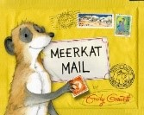 | Can you write a story about your favourite animal? Think carefully about where your animal lives.What might happen if your chosen animal had to live somewhere completely different? | Imagine you are visiting a good friend who has an unusual animal for a pet. Write a postcard home to your grownup describing what the animal is like and how it behaves.  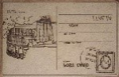
Draw a picture of a castle and label all the different parts we have learned about.  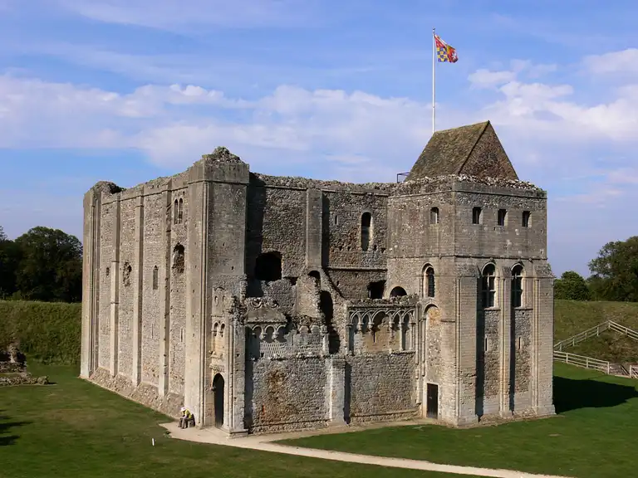 | Design a castle of your own that you would like to live in and describe where you would like to build it.  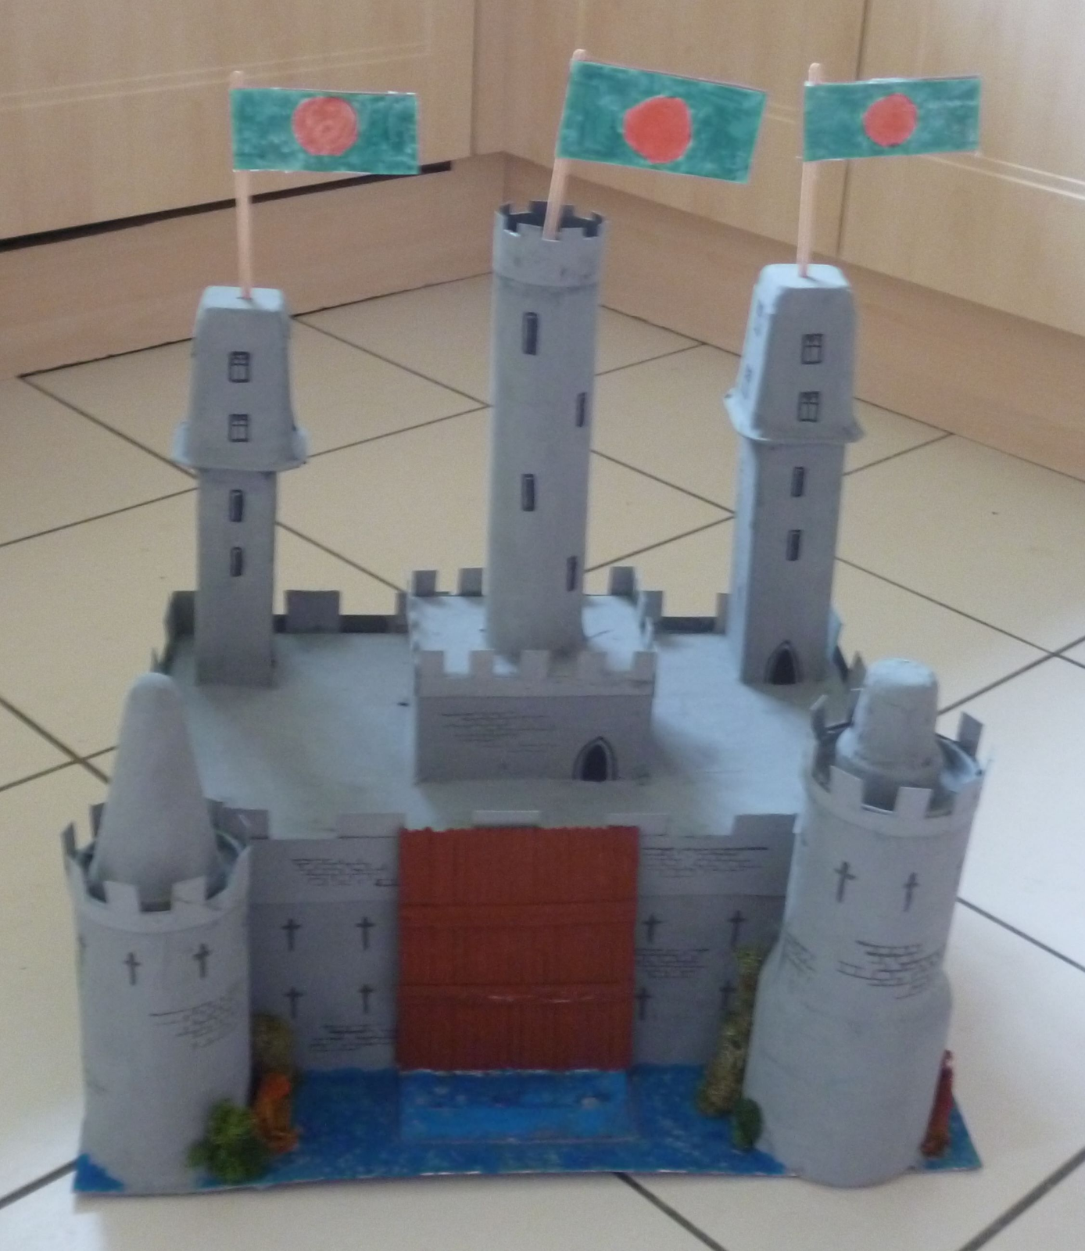 | Write a story called “Castle Adventure”.  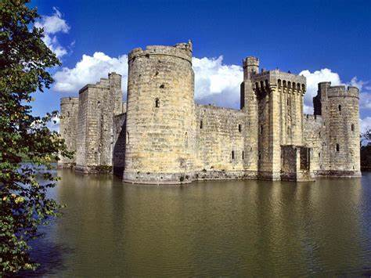
It is now Summer, which flowers can you find in Summer? Draw and label your favourite flower.  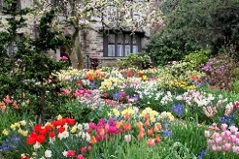 | Can you describe how any plants you are looking after at home are doing? What are you doing to make sure they stay healthy?  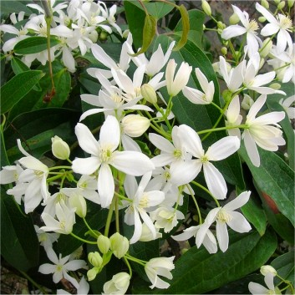 | Can you draw a scientific diagram of a plant and label all the different parts you know?  See if you can find any other parts which we haven’t discussed in School eg: the stamen.  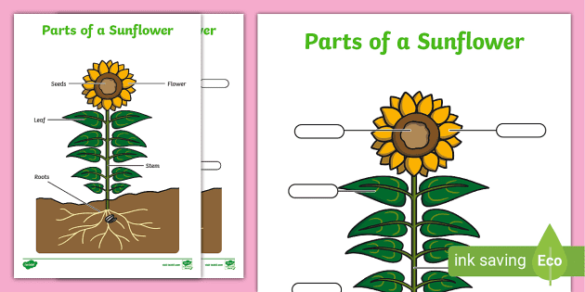
Practise your 2x, 5x and 10x tables.  If you know these, AND YOU SHOULD, practise your 3x and 4x. Try to learn these to bowl your YR3 teacher over.  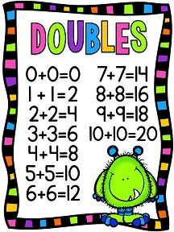 | Practise your number bonds.  Those are the small numbers that add up to 20 or less so you don’t have to keep counting on your fingers in Year 3. EG: 4+7=11  Remember Number Families: If 8+7= 15 then  15 – 8=7 | If you are allowed, do some cooking that includes weighing ingredients in grams and kilograms and measuring liquid in milliletres and litres. If you have a room thermometer at home check the temperatures of the room it is in at different times during the day.  Find a way to record the data you have collected so it can be displayed EFFICIENTLY.

