Topic – can you practice the Kings and Queens song? There’s a link on the webpage. | Science – what is growing in your garden? What other plants can you see around you when you walk to school?  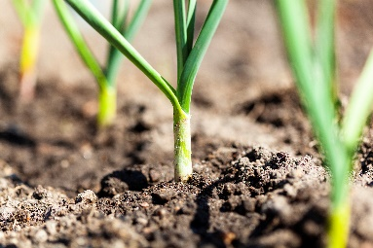 | Art – Can you draw a sunflower? Can you find artists who have drawn sunflowers?  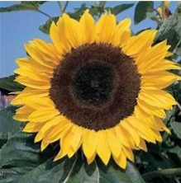
Maths – Use a ruler or tape measure to measure the longest, shortest, biggest, smallest things in your house. Who is the tallest in your family? | Heacham Homework Grid  Email your work to me scook@grf.unity-ed.uk | Computing – where do people use computing in every day life?
English – The Enormous Turnip – Practice acting out the story with your family, or your toys.  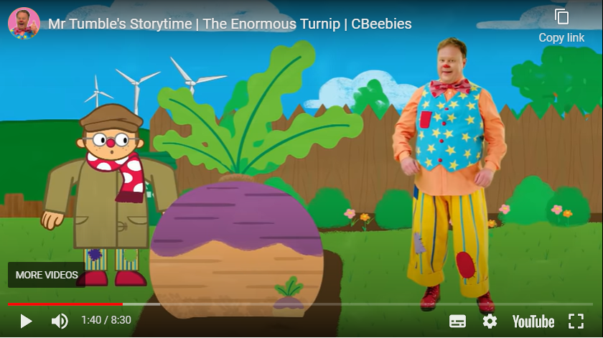 | PHSE – can you smile at one person every day? How does it feel when someone smiles at you? | Practice the oceans and continents songs. Look for the links on the webpage.  