Thornham Homework Grid – Summer 2
We are reading “Meerkat Mail”  Choose an animal and create a fact file about it. Try to find some interesting facts.  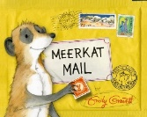 | Can you write a story about your favourite animal? Think carefully about where your animal lives.What might happen if your chosen animal had to live somewhere completely different? | Imagine you are visiting a good friend who has an unusual animal for a pet. Write a postcard home to your grownup describing what the animal is like and how it behaves.  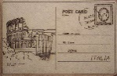
Draw and label a picture of the beach. Include all the things would expect to see. | Design a new game you could play at the beach Can you write instructions too?  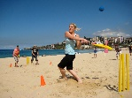 | Research the UK coastline. Can you make a list of some beaches around the UK. Can you put them in alphabet order?  Eg.  Hunstanton Thornham,, Bournemouth
It is now Summer, Which flowers can you find in Summer? Draw and label your favourite flower. | Can you identify animals and their young. E.g. Cat/kitten.  Can you draw the lifecycle of a frog?  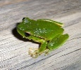 | Can you draw yourself and label your different parts of the body.  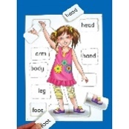
Practise learning your 2x, 5x and 10x tables.  If you know these practise your 3x.  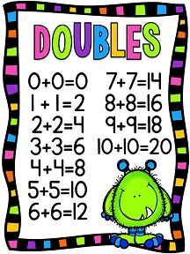 | Can you make up some word problems to include addition and subtraction.  Eg: I have 7 sweets and buy 6 more how many sweets do I have? 7 + 6 = 13. | We still need to build up our staminar after lockdown.  Start by doing 10 star jumps on a Monday.  Add two more each day and see what is the most you can build up to.  Can you do twenty by the following Saturday?  Can you keep adding two more?  If you can’t do ten or can already do more than ten start from where you can and keep adding two. How far can you get?

