Year 5 Homework Grid – Summer 2
Use resources you already have at home to make some coins similar to those in the IC era.  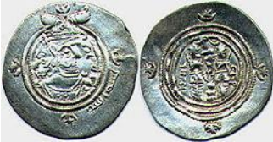 | Make a poster about France, making sure to include landmarks, flag and examples of French that you know. Include the capital city of France and any mountain ranges and main rivers. | Create a piece of artwork inspired by Islamic Art. You could use mosaics, tessellating shapes or colours that are commonly seen in Islamic Art.  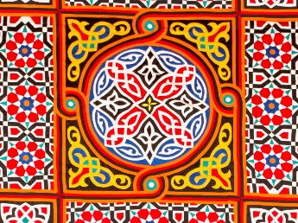 | Make a poster to tell other children in the class about something that is important to you. It doesn’t have to be linked to school learning, but could be about any hobbies or interests you have.
Research in which countries Islamic Civilisation developed and label them on a world map. How many other countries can you label too? Do each in a different colour.  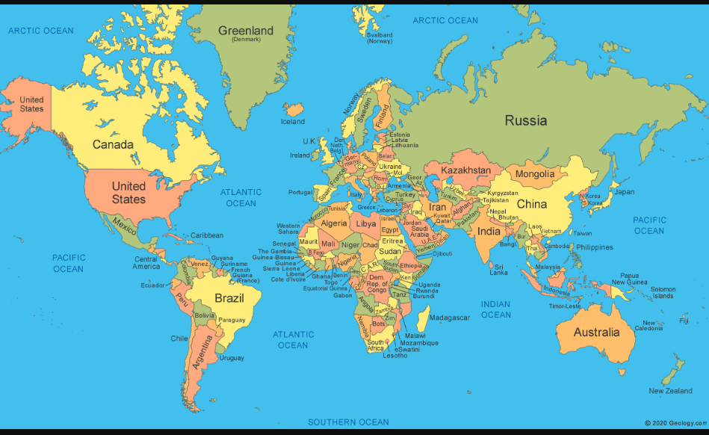 | Listen to some Arabian music. What do you hear in these songs? Which instruments can you identify? How does the music make you feel? Can you recreate any parts of the music you hear? | Plan your own sports day, including all of your favourite events. Can you create any new ones? It should include at least 5 events. | 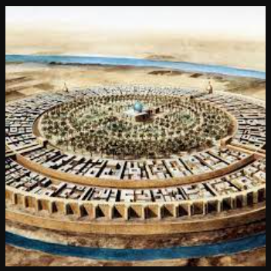  Design your own round city inspired by the round city of Baghdad. Think carefully about what you need to include. If you’re feeling ambitious, have a go at making it using materials you have at home, such as recycled materials.
Use these website links to research Early Islamic Civilisation. Create a multiple choice quiz.  Youtube - Baghdad in 900 AD  Ducksters  School Learning Zone | Visit the library and see if you can find any books to learn more about Early Islamic Civilisation. | Create a Monopoly style game about trading in the Early Islamic Empire. You will need to research important locations. Don’t forget to include chance and community chest cards. | Find as many examples of angles as you can in your house and local area. Take pictures or draw what you’ve found and label them with acute, obtuse, right or reflex.

