Dear parents,

After Christmas Reception will start swimming on a Friday – every week. Mr Holmes, the swimming teacher has come to talk to reception all about swimming and has asked can you send in a swimming bag with a towel swimming costume, swimming hat and goggles (optional). The school have their own arm bands, so you do not need to bring your own.
Everyone needs to have a swimming hat please.
Girl – a one piece swimming costume

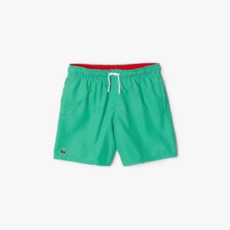
Boys- swim trunks


As part of swimming lessons, the children will need to be getting changed, in and out of swimming costumes and their school clothes, can you please make sure then that your children are able to get themselves dressed, as whilst myself and Miss Ellwood are there to help, we cannot get the whole class dressed.
Thank you
Miss Woodward

