Pupil premium strategy statement
This statement details our school’s use of pupil premium (and recovery premium for the
2023 to 202 academic year) funding to help improve the attainment of our disadvantaged pupils.
It outlines our pupil premium strategy, how we intend to spend the funding in this academic year and the effect that last year’s spending of pupil premium had within our school.

School overview
Detail | Data
School name | Greyfriars Academy
Number of pupils in school | 198
Proportion (%) of pupil premium eligible pupils | 42%
Academic year/years that our current pupil premium strategy plan covers (3 year plans are recommended) | 2025-2026
Date this statement was published | December 2025
Date on which it will be reviewed | November 2026
Statement authorised by | Headteacher (December 2025)
Pupil premium lead | Samantha Howlett
Governor / Trustee lead | Trust Board

Funding overview
Detail | Amount
Pupil premium funding allocation this academic year (2025/26) | £144,505
Pupil premium funding carried forward from previous years (enter £0 if not applicable) | £43,567
Total budget for this academic year  If your school is an academy in a trust that pools this funding, state the amount available to your school this academic year | £188,072

Part A: Pupil premium strategy plan

Statement of intent
Inclusion and equality are at the heart of everything we do at Greyfriars. As such, the purpose of our Pupil Premium Strategy is to enable our disadvantaged pupils to fully access all areas of the curriculum so that they make excellent progress from their individual baselines, both in their personal, social and emotional development and in their academic learning. We aim to narrow/eliminate the gap between the educational outcomes of our disadvantaged pupils and the outcomes of non- disadvantaged pupils nationally.
Through our strategy we aim to address the specific challenges faced by disadvantaged pupils in our school so that they overcome the barriers to achievement.
We will address the challenges faced by disadvantaged pupils through strategic planning of structured learning and support at whole class, group and individual level.
‘Assess, Plan, Do and Review’ will underpin our strategic planning to ensure equity of curriculum access and good progress.

Challenges
This details the key challenges to achievement that we have identified among our disadvantaged pupils.
Challenge number | Detail of challenge
1 | Poor Reading, oral language skills and limited vocabulary.
2 | Low EYFS baseline on entry.
3 | Social, Emotional, Mental health (SEMH).
4 | Lack of aspirations and cultural capital experiences.
5 | Low attendance and lack of parental engagement in support of learning.

Intended outcomes
This explains the outcomes we are aiming for by the end of our current strategy plan, and how we will measure whether they have been achieved.

Intended outcome | Success criteria
EYFS pupils make excellent progress from their baselines so that a greater proportion reach GLD. | Developmental gaps between PP pupils and others have been narrowed or eliminated. This is evidenced by the proportion of PP pupils reaching GLD from low baselines.  GLD for PP is in line with national outcomes.
Pupils in KS1 and KS2 make good progress in Reading so that a greater proportion reach age-related expectations at end of Key Stage | Progress measures are inline or better than national in KS2 Reading.  Y1 Phonics Test outcomes are in line with national and Phonics Tracker shows good progress for individuals.  End of year Reading assessments show good progress over year.
Pupils in KS1 and KS2 make excellent progress in Writing so that a greater proportion reach age-related expectations at end of Key Stage. | Progress measures are inline with national in KS2 Writing.  End of year Writing assessments show good progress over year.  Good progress is evidence between cold and hot tasks in pupils’ books.
Pupils in KS1 and KS2 make excellent progress in Maths so that a greater proportion reach age-related expectations at end of Key Stage. | Progress measures are inline national in KS2 Maths.  End of year Maths assessments show good progress over year.  Termly Maths assessment evidence identified gaps have been addressed and individual progress made.
Emotional well-being and behavioural issues have been effectively addressed so that all children are able to access the curriculum and their learning effectively. | Teachers can evidence improvement in emotional well-being and self-regulation of specific pupils. Evidence of pupils’ progress and achievement supports this.
Pupils have developed their vocabulary and language skills in support of their confidence, speaking and listening, reasoning and learning. | Children have developed subject specific vocabulary and are effectively using oral language and dialogic skills to articulate and develop their thinking and understanding. This is having a positive impact on their Reading and Maths, evidenced by the teacher, work in books and assessments.
Attendance of pupil premium children is good. | Attendance of PP pupils is in line with national average.

Activity in this academic year
This details how we intend to spend our pupil premium this academic year to address the challenges listed above.

Teaching (for example, CPD, recruitment and retention)
Budgeted cost: £34,100

Activity | Evidence that supports this approach | Challenge number(s) addressed
School based CPD Improving ‘Quality First Teaching’ underpinned by Rosenshine’s Principles. (Walkthrus)  CPD will be provided via staff meetings and twilight sessions. Time  will be given for professional reflection and colleague mentoring sessions.  £3000 | EEF-  Identifies the effectiveness of good quality teaching incorporating focused assessment techniques and good quality of feedback. | 1,2,3,4,5
Professional Development of staff through opportunities to engage with NPQs  NPQEL  NPQH  NPQSL  NPQSEND X 3  Release time  £5000 | EEF – Professional Development Report  Ensure that professional development aligns with the needs of the school and is supported by school leadership. Gaining ongoing leadership buy-in can facilitate successful implementation.  Recognise the time constraints faced by teachers and adapt professional development accordingly. Those designing and selecting PD should critically assess how a PD programme will fit in with the school routine. | 4,5
Maths Mastery Programme – White Rose Maths’ implemented across the school.  Cost Implication:  White Rose Maths – for 2025/26 – costs for programme and resourcing £600  PIXL membership | NCETM- ‘Teaching for Mastery In Primary Schools’ evidences the effectiveness of the approach in improving pupils’ understanding and outcomes in Maths.  In school evidence also supports improved pupil confidence and progress in Maths.  Mastery in number Rec – 2 Cambridge Math Hub | 1, 2, 3, 4
CUSP Reading Yr 1 – 6  Implementation of revised Reading programme.  Additional cost of material  £3000 | Targeted academic support can support pupil progress and can be employed to help boost language development, literacy, or numeracy as well as other subject areas. Interventions should be carefully linked to classroom teaching and matched to individual pupils’ specific needs, while not inhibiting their access to the wider curriculum. | 1
RWI Phonics Programme - £6500 and £7000 from Wensum Hub project  Total cost - £13,500  (£1000 subscription, £600 development day – discount to £1200) – consumables | SSP accredited programme funded and implemented with the full training and CPD package from Ruth Miskins for all staff. | 1,2,4
Music Provision through visiting teacher service provision (£5000) & Resources to improve outcomes (4000) | Provision for learners to access Music from specialist visiting teacher | 3, 4

Targeted academic support (for example, tutoring, one-to-one support structured interventions) Budgeted cost: £78,800
Activity | Evidence that supports this approach | Challenge number(s) addressed
Phonics intervention in EYFS Cost:  - 1 x 28hrs - £22,700 | EEF: 7+ months additional progress  Member of Read, Write Inc trained in 2025/26. Updated training and maternity cover teacher trained. | 1, 2, 3
Focused intervention (small group and 1:1 sessions) in Reading/Phonics, Writing and Maths provided by Teaching Assistants in all Phase Teams.  Cost:  - 2 x 28hrs  Intervention TAs-  £45,400 | School based and EEF evidence: Focused intervention based on identified pupil need, incorporating adult modelling, ongoing assessment and immediate feedback has been effective in improving progress in Phonics, Reading, Writing and Maths. | 1, 2
Standardisation of assessments and interventions (2025/26)  PIXL (£3,500) | As part of review of assessment and interventions standardisation across the Trust, benefit of sharing practice and enabling all teachers and TAs to intervene effectively with the PIXL Therapies | 1,2,4
Additional intervention:  Before & After School  Small group ‘Catch Up’ sessions led by Teachers (booster classes – Year 6 and Year 1 Phonics)  Thrive, Lexia Chromebook bundle  £7200 | School based and EEF evidence: Focused intervention based on identified pupil need, incorporating adult modelling, ongoing assessment and immediate feedback has been effective in improving progress in Phonics, Reading, Writing and Maths. | 1, 3, 4, 5

Wider strategies (for example, related to attendance, behaviour, wellbeing)
Budgeted cost: £50,000
Activity | Evidence that supports this approach | Challenge number(s) addressed
Attendance officer employed to monitor attendance and support families where the need for improvement is identified.  Transport support – Bus passes | School records provide evidence that early identification of poor attendance, with Attendance officer intervention/liaison with families to clarify expectations and address underlying reasons has led to improved attendance outcomes. | 3, 5
Emotional and Mental Health Intervention provided by Mental Health  Champion and  Specialist EMH  Teaching Assistant.  Cost:  Resources- £1000 | Regular small group and 1:1 sessions, (both following a structured programme and in response to need) have developed emotional literacy, increased self-esteem and supported pupils’ self-regulation and anger management. This has then enabled them to be more- ready to learn. | 3, 4, 5
Provision of Sensory Circuits 4x weekly- led by Specialist EMH Teaching Assistant  Cost: included in TA costs above | School evidence shows that these morning sessions enable pupils with significant EMH needs and challenging behaviour to be better motivated for school, calmer and more ready to learn. This has also had a positive impact on the attendance and punctuality of some pupils. | 3, 4, 5
Children are able to attend school residential and other out of school educational visits/clubs subsidised by PP funding where needed. Cost: £6000 | Extracurricular activities are an important part of education in their own right. These approaches may increase engagement in learning but it is important to consider how increased engagement will be translated into improved outcomes. | 3,4
All children can access Cultural Capital opportunities, eg. visiting the Theatre, and other in school visits, subsidised by PP  funding Cost: £3,000 | budget available for subsidising costs for trips and visits this year 2025/26. | 3, 4
All children can attend school regularly and punctually, attending ‘Before & After School Club’ as needed and wearing correct uniform and with correct PE kit. Subsidised by PP funding where needed. Cost: (£1000) | There is some evidence that providing free, universal, before-school breakfast clubs can benefit pupils by preparing them for learning or supporting behaviour and school attendance. Our independent evaluation of the Magic Breakfast programme | 4, 5
Provision of additional sessions from Swimming Instructor based on site supporting swimming for pupils (NOT in Year 2 and Year 6’s supported by statutory expectations for swimming)  On basis of 1hr/week for full academic year, budgeted for Year 3/4/5 sessions (equivalent of 3 hours/week on basis of £1400/year for 1 hr/week = £6000 | Opportunities for children to benefit from the on-site pool and instructor for swimming opportunities within school time which would not be possible for children and families without a cost out of school. Also used for our most vulnerable learners and as a reward option for children across the school. | 3,4
Transportation costs to participate in Music and other cultural/ community events  £3000 | Extracurricular activities are an important part of education in their own right. These approaches may increase engagement in learning but it is important to consider how increased engagement will be translated into improved outcomes. | 4
Additional resources to support EYFS continuous provision-  In order to promote attendance in the early years |  | 2,5

Total budgeted cost: £162,900

Part B: Review of outcomes in the previous academic year

Pupil premium strategy outcomes
This details the impact that our pupil premium activity had on pupils in the 2024-2025 academic year.
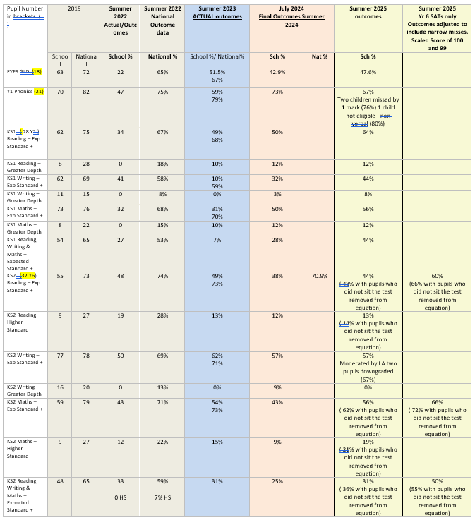

Externally provided programmes
Please include the names of any non-DfE programmes that you purchased in the previous academic year. This will help the Department for Education identify which ones are popular in England
Programme | Provider

Service pupil premium funding (optional)
For schools that receive this funding, you may wish to provide the following information:
Measure | Details
How did you spend your service pupil premium allocation last academic year? | N/A
What was the impact of that spending on service pupil premium eligible pupils? | N/A

Further information (optional)
Use this space to provide any further information about your pupil premium strategy. For example, about your strategy planning, or other activity that you are implementing to support disadvantaged pupils, that is not dependent on pupil premium or recovery premium funding.

